**How to Bake Perfect Cookies From Scratch**

Have you ever wondered how other people get their homemade cookies to look like they came from a bakery? It's all in the right ingredients, techniques, and tools. Here's everything you need to know to bake perfect cookies from scratch.

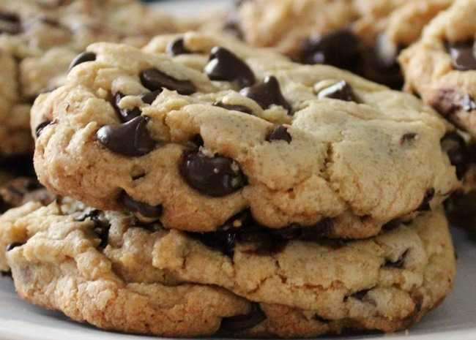

*Best Big, Fat, Chewy Chocolate Chip Cookie | Photo by cherryberry*

**Try this recipe:**[**Best Big, Fat, Chewy Chocolate Chip Cookie**](https://www.allrecipes.com/recipe/25037/best-big-fat-chewy-chocolate-chip-cookie/)

**Ingredients**

Using the correct ingredients in their proper ratios is crucial to good baking. For best results, follow the recipe and [measure ingredients correctly](https://www.allrecipes.com/video/30/how-to-measure-ingredients/).

**Flour**

Most cookie recipes call for all-purpose or pastry flour. If you use bread flour with its high gluten protein content, or cake flour, which is high in starch, you'll end up with cookies that tend to spread less when you bake them. Recipes for [shortbread cookies](https://www.allrecipes.com/recipes/855/desserts/cookies/butter-cookies/shortbread-cookies/) or other cookies with a crumbly texture usually have a higher flour-to-liquid ratio.

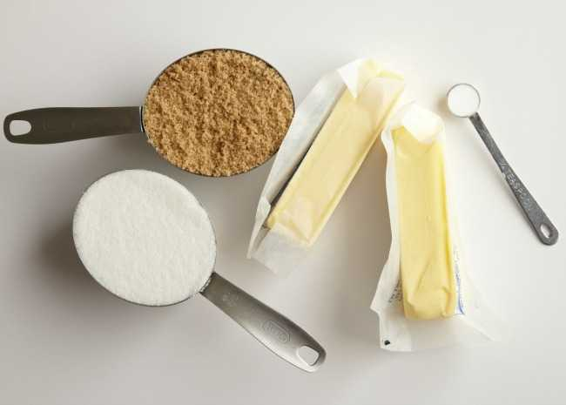

*Photo by Meredith*

**More:** Get the inside scoop on different types of [wheat flour](http://dish.allrecipes.com/all-about-flour/) and [gluten-free flour](http://dish.allrecipes.com/gluten-free-flours-and-recipes/), including [coconut flour](http://dish.allrecipes.com/all-about-coconut-flour/).

**Leaveners**

These are the ingredients that make baked goods puff up. In cookie recipes, the two most common leaveners are baking soda and baking powder.

* Baking soda is simply bicarbonate of soda. It neutralizes the acidity of the dough, allowing the cookies to brown in the oven.
* Baking powder is a combination of bicarbonate of soda plus cream of tartar, an acidic ingredient. Since baking powder already contains its own acid, it will not reduce the acidity in the dough, and the resulting cookies will be puffier and lighter in color.

**More:** Learn how to use [baking soda and baking powder](http://dish.allrecipes.com/baking-soda-and-baking-powder-whats-the-difference/) in your recipes for best results.

**Fats**

Fats are all about flavor and spread—what a cookie tastes like, and whether it keeps its shape or flattens as the fats heat and liquify in the oven. In general, more fat in the recipe produces flat, crispy cookies, while less fat produces puffier, cake-like cookies. The kind of fat you use also makes a difference. Cookies are made primarily with butter, margarine or shortening, and each behaves differently. Note that whipped spreads are not suitable for baking.

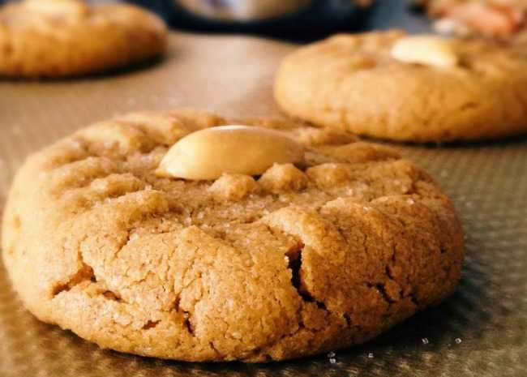

*Photo by Buckwheat Queen*

* Cookies made with butter tend to spread out because it melts at body temperature—a much lower temperature than other solid fats—resulting in a “melt-in-your-mouth” burst of flavor. In fact, butter is an essential flavor agent in certain cookies, such as shortbreads. If cookies spread more than you'd like them to, try lowering the amount of butter, sugar, or baking soda in the recipe.
* Shortening has a much higher melting point than butter, and will help cookies keep their original unbaked shapes.
* Margarine has a only a slightly higher melting point than butter.

More: Learn more about the [difference between using butter and margarine](http://dish.allrecipes.com/butter-vs-margarine-whats-better-for-baking/) in your baking recipes.

**Sugars**

Like fats, sugars liquefy when they heat in the oven. The type and amount of sugar both play a big role in cookie performance.

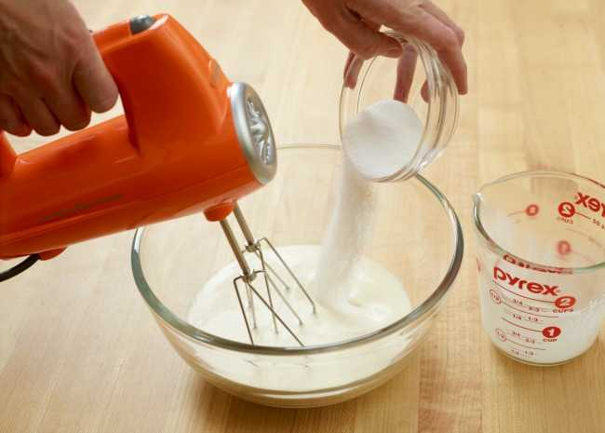

*Photo by Meredith*

* White sugar makes a crisper cookie than does brown sugar or honey.
* Cookies made from brown sugar will absorb moisture after baking, helping to ensure that they stay chewy. Most chocolate chip cookie recipes contain both brown and white sugars.
* If you lower the amount of sugar called for in a cookie recipe, the final baked cookie will be puffier than its high-sugar counterpart.

**More:** Find out how to bake with different [sugars and sugar substitutes](http://dish.allrecipes.com/baking-with-sugar-and-sugar-substitutes/).

**Eggs and Liquids**

Eggs are a binding agent, holding ingredients together. Egg yolks add richness but allow a crisp texture after baking, but egg whites tend to make cookies dry and cakey. To make up for the drying effect of the egg whites, extra sugar is often added. This is why cookies made with just egg whites tend to be so sweet—think of light and airy [French macarons](http://dish.allrecipes.com/how-to-make-macarons/). Liquids can either cause cookies to puff up or spread. If egg is the liquid, it will create a puffy, cake-like texture. Just a tablespoon or two of water or other liquid will help your cookies spread into flatter and crisper rounds. **More:** Learn [more about eggs](http://dish.allrecipes.com/all-about-eggs-grades-safety-and-nutrition/), plus decode the difference in egg grades. Also, discover the [9 ingredients every baker needs](http://dish.allrecipes.com/essential-baking-ingredients/).

**Technique Tips**

Mixing cookie dough doesn't require as delicate a touch as mixing cake batter, but it's still important to get it right. Some recipes require a creaming step in which the fat and sugars are beaten together until light-colored and fluffy. Other cookies require a sandy texture, so the fat is cut into the flour. Over-mixing can incorporate too much air into the dough, resulting in flat, overly spread-out cookies. Always read through and follow the recipe instructions.

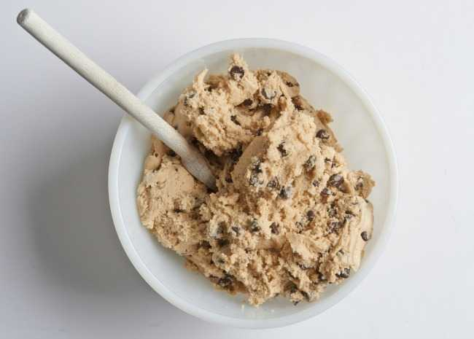

*Photo by Meredith*

**Temperature**

Oven temperature isn't the only important factor in how your cookies turn out. Ingredient temperature makes a difference, too: **Ingredient Temperature** Have all ingredients at room temperature before mixing the dough, unless your recipe specifically says otherwise. This helps all the different kinds of ingredients come together evenly. After you mix the dough, you can chill it so it holds its shape better as it bakes. Rolled and [cut-out cookies](https://www.allrecipes.com/recipes/844/desserts/cookies/cut-out-cookies/) should be refrigerated before baking for sharper, clearer edges. [Drop cookies](https://www.allrecipes.com/recipes/16394/desserts/cookies/drop-cookies/), such as [chocolate chip](https://www.allrecipes.com/recipes/839/desserts/cookies/chocolate-chip-cookies/) or [oatmeal cookies](https://www.allrecipes.com/recipe/19247/soft-oatmeal-cookies/), can be at room temperature before baking; the spoonfuls of dough will spread and flatten out to the desired result. **Oven Temperature** Buy an [oven thermometer](http://shop.allrecipes.com/shop/essentials/kitchen-tools/thermometers-a1925500999.html) to be sure your oven temperature is calibrated correctly. They don't have to be expensive, and you'll be surprised by how different your actual oven temperature can be from what it says on your oven dial or digital read-out. Generally, cookies are baked in a moderate oven—350 degrees F (175 degrees C)—for 8 to 12 minutes, depending on the size of the cookie.

* For chewy cookies, allow them to cool on the pan for 3 to 5 minutes before transferring to a [cooling rack](http://shop.allrecipes.com/shop/essentials/baking-and-pastry-tools/cooling-racks-a1106938716.html).
* For crispier cookies, let cookies cool for one minute on the baking sheet before transferring to a cooling rack.

**More:** This handy [temperature conversion chart](http://dish.allrecipes.com/temperature-conversions/) shows Fahrenheit to Celsius equivalents.

**Tool Time: Baking Sheets and More**

Different kinds of [baking sheets](http://shop.allrecipes.com/shop/bakeware/cookie-sheets-a1022153234.html) produce different results.

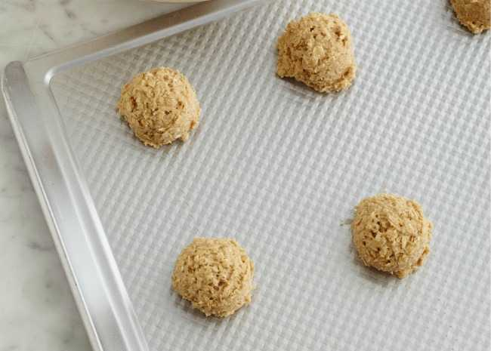

*Photo by Meredith*

* Thin baking sheets might allow the bottoms to brown too fast.
* Insulated baking sheets allow air movement and help cookies bake evenly, but they can be expensive.
* Cookie baking sheets without rims allow cookies to easily slide off the sheet when they're used with a liner (see below).
* Semi-thick rimmed baking sheets—also called jellyroll pans—are available just about everywhere, and are a fine multipurpose baking choice.

**Liners**

To keep cookies from sticking to the baking sheet, buy a roll of parchment paper or invest in a [nonstick baking mat](http://shop.allrecipes.com/shop/essentials/baking-and-pastry-tools/baking-mats-a785490963.html) to make cookie removal and clean-up easy. Inexpensive parchment paper can be used again and again, and slides right off the sheet onto the cooling rack. **Don't use** waxed paper as a baking sheet liner.

**Scoops**

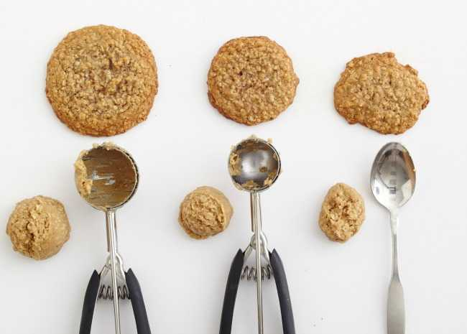

*Photo by Meredith*

When you're baking mass batches of cookies, or when you really want to make sure your cookies come out the same size, use a spring-loaded scoop to measure out the dough quickly and evenly. Scoops come in various sizes, and you'll find yourself using them for more than cookie dough.

**Troubleshooting Cookie Problems**

If you have a cookie recipe that you love, but aren't getting the desired results, use these tips to get your perfect cookie:

* **How to make cookies flatter:** If you want your cookies on the flat side, you can do some or all of the following things: Use all butter, use all-purpose flour or bread flour, increase the sugar content slightly, add a bit of liquid to your dough, and bring the dough to room temperature before baking.
* **How to make cookies puffier:** For light, puffy cookies, use shortening or margarine and cut back on the amount of fat; add an egg, cut back on the sugar, use cake flour or pastry flour, use baking powder instead of baking soda, and refrigerate your dough before baking.
* **How to make cookies chewier:** Try melting the butter before adding it to the sugars when mixing. Remove cookies from the oven a few minutes before they are done, while their centers are still soft but are just cooked through. The edges should be golden. Use brown sugar, honey, or molasses as a sweetener. Let cookies cool on the pan for several minutes after baking before transferring to cooling rack.
* **How to make cookies crispier:** For crisp, crunchy cookies, use all butter and a proportion of white sugar. Use egg yolks in place of a whole egg. Cookies should be baked completely. Let cool on the baking sheet for one minute before transferring to a cooling rack.

**10 Quick Tips for Better Cookies**



*Christmas Cookies | Photo by Meredith*

**Find all your favorite**[**Christmas cookie recipes**](https://www.allrecipes.com/recipes/841/holidays-and-events/christmas/desserts/christmas-cookies/)**.**

1. Use the best quality ingredients for the tastiest cookies.
2. Always use large-size eggs, unsalted butter and nuts, and pure extracts of vanilla or almond.
3. Successful baking relies on the correct ratio of ingredients, so be sure to [measure accurately](https://www.allrecipes.com/video/30/measuring-ingredients/).
4. Most cookie recipes call for [all-purpose flour](http://dish.allrecipes.com/all-about-flour/). For the best results, lightly spoon flour into a dry measuring cup and level with a knife. Do not sift unless the recipe specifically says to do so.
5. Unless you are baking with non-stick pans and cookie sheets, use parchment paper for stick-free baking and easy clean-up.
6. Chill dough for [cut-out cookies](https://www.allrecipes.com/recipes/844/desserts/cookies/cut-out-cookies/), and soften it up at room temperature for a few minutes before rolling out.
7. Leave at least two inches of space between cookies so they don't spread into each other.
8. Adjust baking times to achieve the cookie texture you crave. A little less time produces chewier cookies; a little more time makes them crispy.
9. Bake [bar cookies](https://www.allrecipes.com/recipes/836/desserts/cookies/bar-cookies/) in the pan size indicated in the recipe.
10. Cool cookies completely before [decorating](http://dish.allrecipes.com/how-to-decorate-cookies/).

**While We're Talking Cookies...**

* Ready to get baking? See our [complete cookie recipe collection](https://www.allrecipes.com/recipes/362/desserts/cookies/).
* Check out techniques and ideas for [decorating cookies](http://dish.allrecipes.com/how-to-decorate-cookies/).
* Planning ahead? Get tips to [freeze cookies and cookie dough](http://dish.allrecipes.com/freezing-cookies-and-cookie-dough/).
* Get all the tips and recipes you need to [make sugar cookies](http://dish.allrecipes.com/how-to-make-sugar-cookies/) for any occasion.
* If you want to [ship cookies](http://dish.allrecipes.com/how-to-mail-cookies/), these [recipes won't crumble in the mail](http://dish.allrecipes.com/10-christmas-cookies-to-mail/).